Enhancing E-commerce Development with Automated Testing Tools: Insights from Selenium

An Assignment submitted in partial fulfillment of the requirements for the degree of
Bachelor of Science
in
Computer Science

CS 2401: Software Engineering 1
Term 5 – 2025
University of The People

October 8, 2025

Enhancing E-commerce Development with Automated Testing Tools: Insights from Selenium

Introduction
Automated testing tools are vital in contemporary software development, particularly for e-commerce platforms where reliability and speed are essential. By streamlining the quality assurance process, minimizing manual errors, and accelerating testing cycles, robust automated solutions have become indispensable. For software teams working on web-based e-commerce applications, choosing and implementing effective automated tools such as Selenium can improve both the efficiency and quality of development. This essay examines three key features of automated testing tools that enhance development, explains integration into CI/CD pipelines, and analyzes significant implementation challenges. These aspects provide clear insight into how automation can optimize e-commerce projects, setting the stage for a deeper exploration of its core benefits and obstacles.

Key features of automated testing tools
Automated testing tools offer several features that make a substantial difference in the development cycle of an e-commerce platform. The first is cross-browser compatibility, see Figure 1. Selenium, for instance, abstracts browser differences and allows tests to run reliably on Chrome, Firefox, Internet Explorer, and others (Selenium, 2024). This ensures that users experience consistent behavior across browsers, which is crucial for platforms serving a diverse customer base. Developers benefit from writing reusable and dependable test scripts, reducing maintenance for multiple browsers and facilitating thorough regression and acceptance testing (Selenium, 2022). Moving from compatibility, a second critical feature is the use of flexible automation frameworks.
Figure 1
Cross-browser compatibility
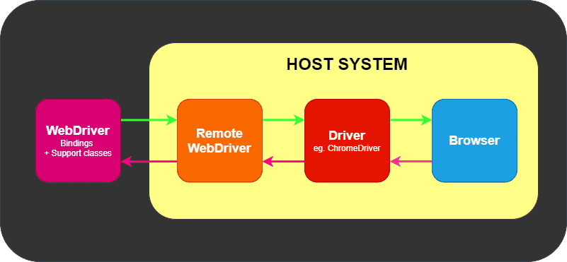
Framework integration is the second major feature, as shown in Figure 2. Selenium works with popular frameworks such as JUnit for Java and NUnit for .NET, which help structure, organize, and execute test cases efficiently (Selenium, 2024, September 10). These frameworks support advanced testing methodologies, including Test Driven Development (TDD) and Behavior Driven Development (BDD), encouraging collaboration and best practices among development and quality assurance teams. By automating functional, integration, and system tests, teams can validate components and workflows, smoothing the path to continuous improvement (Selenium, 2024). Building upon framework support, the next essential feature is scalability for distributed testing.
Figure 2
Test framework integration
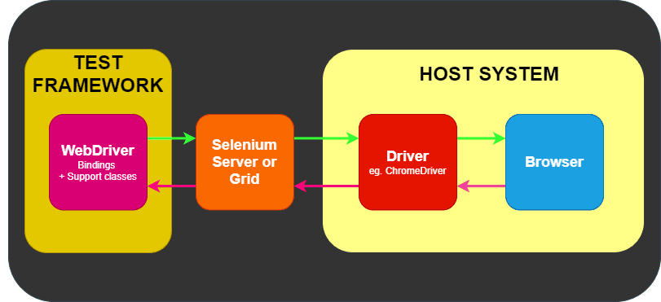
Scalability through distributed testing is crucial for e-commerce platforms facing high user loads and frequent changes. Selenium Grid enables simultaneous execution of test cases across multiple machines and platforms, allowing for large-scale regression and performance tests that mimic real-world traffic scenarios (Selenium, 2025). This parallelization reduces testing time and increases coverage, making it possible to adapt quickly during busy shopping periods or sales events. As development cycles accelerate, a scalable testing strategy becomes the foundation for consistent quality and reliability. These three features set the stage for efficient integration into CI/CD pipelines.

Integration into CI/CD pipeline
Integrating automated test tools within the CI/CD pipeline is essential for improving testing efficiency and receiving timely feedback during development. CI/CD systems like Jenkins or Azure DevOps are configured to trigger automated test suites with every code commit or pull request, enabling Selenium tests, which are organized via established frameworks to run as part of the build process (Selenium, 2024). Results are delivered instantly to developers, ensuring early defect detection and reducing the likelihood of problematic releases. Automated testing within CI/CD pipelines supports continuous delivery, letting the e-commerce system evolve rapidly without sacrificing quality (Selenium, 2024). The benefits of integration, however, are best understood alongside the challenges teams may face.

Challenges in implementation
Despite their advantages, automated testing tools present several challenges during implementation. The first is maintenance overhead. Automated test scripts, especially those interacting with complex or dynamic interfaces, require frequent updates and reviews to stay effective as the application evolves (Selenium, 2024). Layout changes, workflow adjustments, or logic updates can disrupt tests, demanding dedicated resources to keep automation in sync with the codebase. This introduces the next hurdle, test flakiness.
Test flakiness occurs when automated tests yield inconsistent results due to timing issues, asynchronous operations, or environmental variance. Selenium tests that interact with browsers are particularly prone to such problems, which can arise from page rendering delays or network instability (Selenium, 2024). Flaky tests erode trust in automation and make it challenging to differentiate genuine defects from false positives. Addressing flakiness requires improved test design, smarter handling of wait conditions, and minimizing reliance on unstable elements. The third challenge is integration complexity.
Integration complexity emerges when aligning automated testing tools with established workflows and CI/CD infrastructure. Compatibility concerns with build systems, source control, and deployment platforms can hinder seamless operation. Setting up distributed testing environments, such as Selenium Grid, also demands technical expertise and careful planning (Selenium, 2022). Additionally, teams must manage test data, secure test environments, and coordinate parallel execution to ensure reliable automation. Overcoming these challenges is vital for sustainable and effective test automation. With these obstacles in mind, the conclusion highlights the importance of strategic planning and informed tool selection.

Conclusion
Automated testing tools like Selenium provide transformative benefits for e-commerce development, including cross-browser compatibility, structured automation frameworks, and scalable distributed testing. Integrating these solutions into CI/CD pipelines enables rapid feedback and continuous delivery, allowing teams to adapt to changing requirements while maintaining high standards. Nevertheless, successful adoption requires careful attention to maintenance, flakiness, and integration challenges. By proactively addressing these issues and leveraging the strengths of automation, development teams can deliver robust, efficient, and adaptable e-commerce applications in a fast-paced digital environment.

References
Selenium. (2022, September 4). Selenium components. https://www.selenium.dev/documentation/overview/components/
Selenium. (2024, September 10). Overview of test automation. https://www.selenium.dev/documentation/test_practices/overview/
Selenium. (2024, November 7). A deeper look at selenium. https://www.selenium.dev/documentation/overview/details/
Selenium. (2024, February 6). Selenium overview. https://www.selenium.dev/documentation/overview/
Selenium. (2025, March 9). Types of testing. https://www.selenium.dev/documentation/test_practices/testing_types/

